Setting Up rNOMADS and wgrib2 for R

Sources:

<https://www.r-bloggers.com/2015/04/how-to-install-rnomads-with-grib-file-support-on-windows/>

<https://bovineaerospace.wordpress.com/2015/04/26/how-to-install-rnomads-with-grib-file-support-on-windows/>

# Install “rNOMADS” Package in R Studio

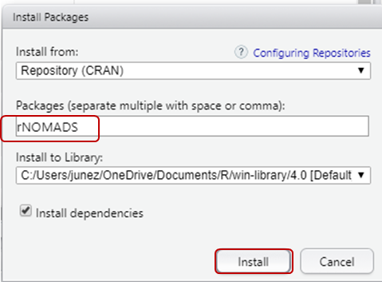

# Download the wgrib2.exe and all DLL files

Download the .zip file from <https://github.com/mhdella/Weather_Grip_files> (see below).

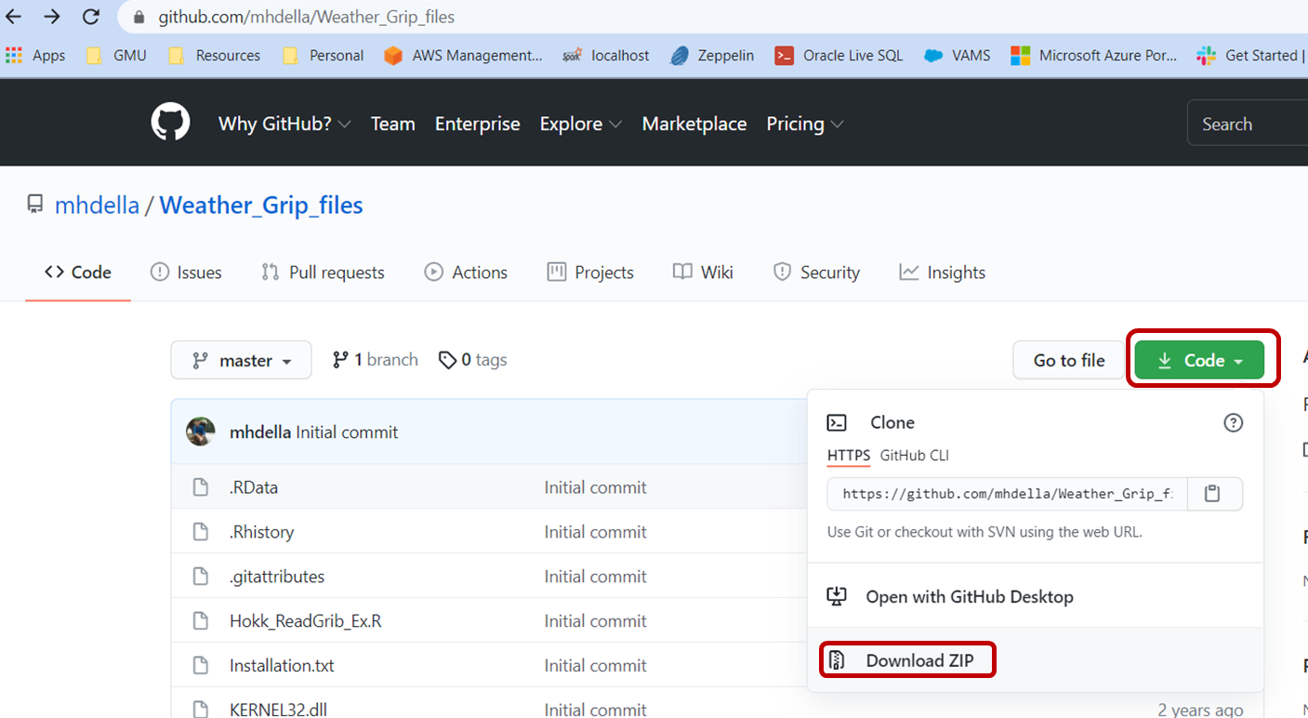

Unzip the file, as exhibited below.

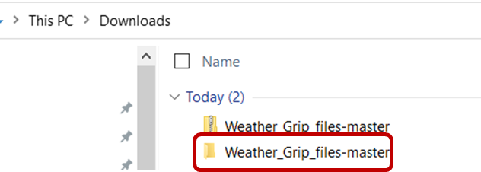

# Create a new directory in the local machine

“C:/Program Files/wgrib2” should work. I set up mine in “C:\BigData\wgrib2” as shown below.

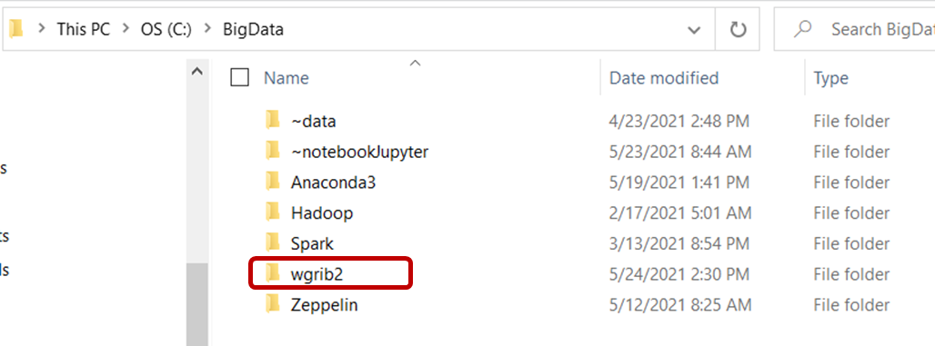

# Copy all subdirectories and files from Step 2 in the newly created wgrib2 Directory

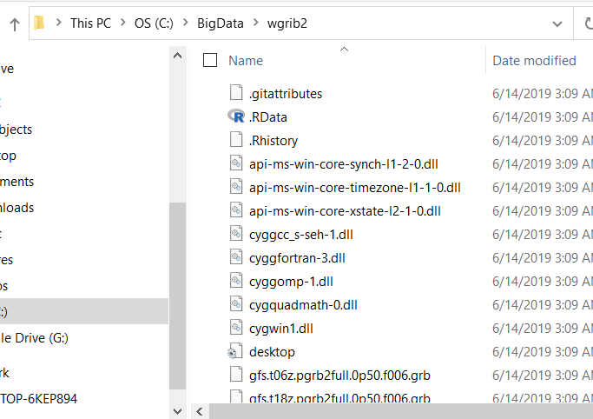

# Append the directory path to the Windows PATH variable

Use the search as shown below. Open the “Edit the system environment variables” and Open (see below).

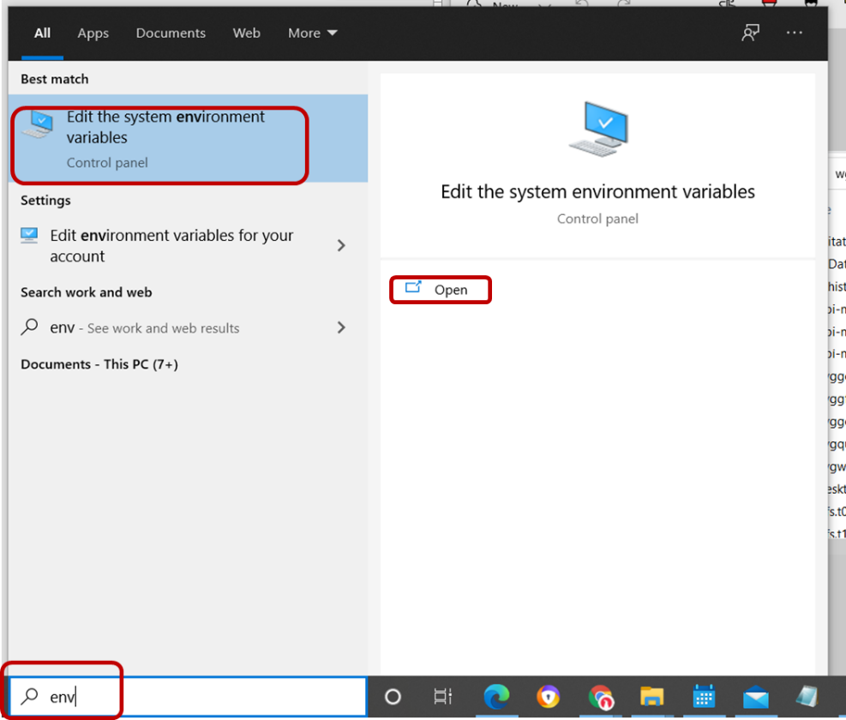

Under Advanced Tab, select Environment Variables.

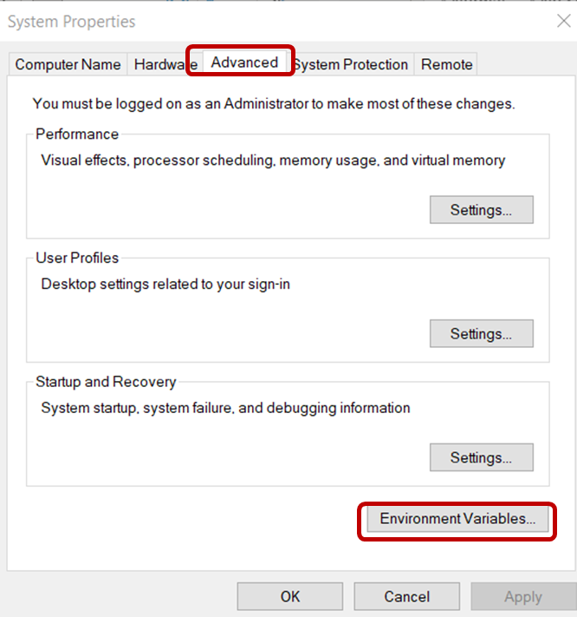

Select “**Path**” under “User variables…” and Select **Edit**..

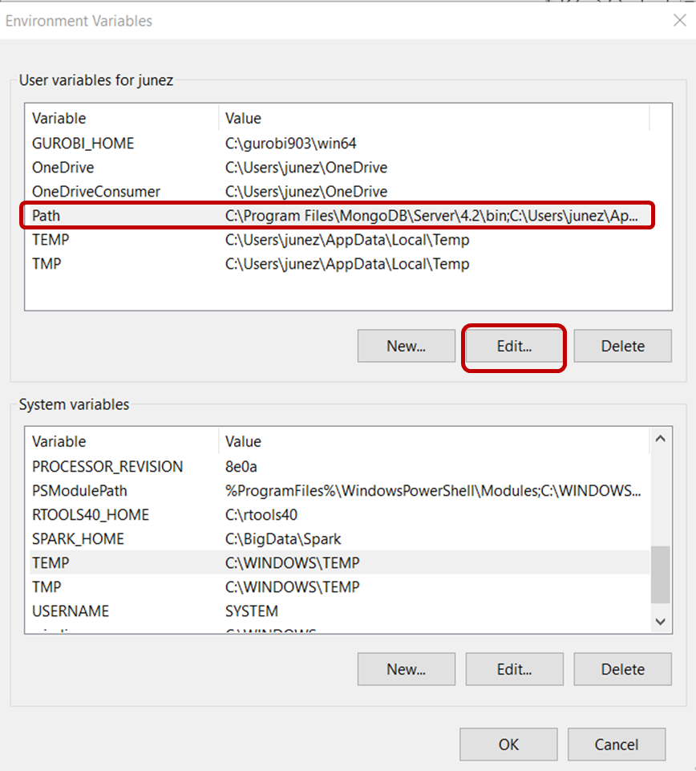

Select **New** then **Browse**.

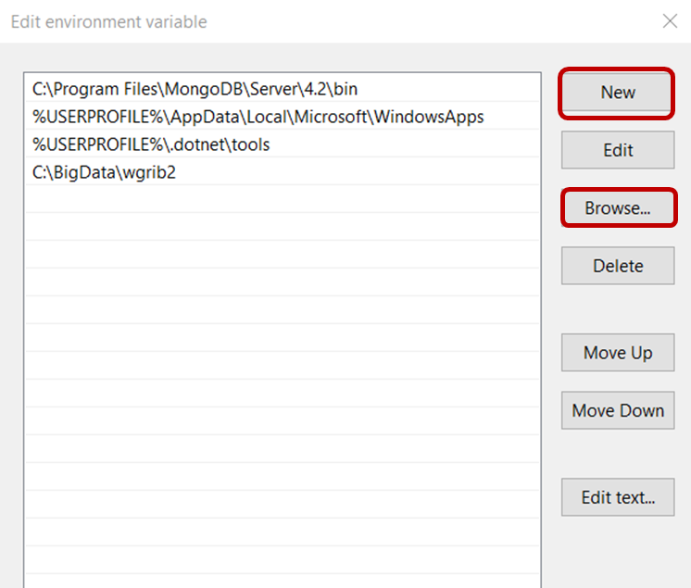

Select “C:\BigData\wggrib2” (or the new directory created in Step 3).

Click **OK** and **OK** for all subsequent windows.

# Test to see if worked correctly

If R is open, close and reopen it. Then try the following command in the R interpreter: system("wgrib2"). If you see something similar to below, then you’re all set.

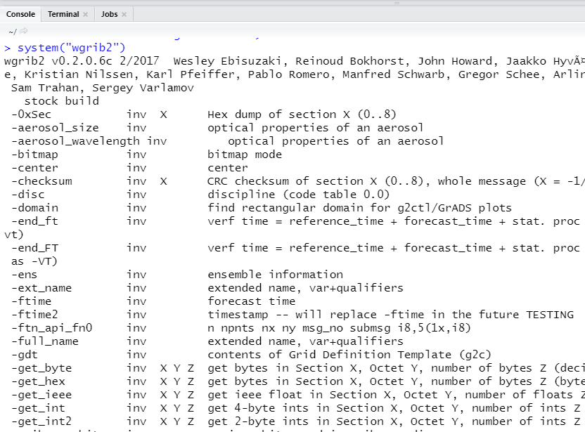

# Related Sites

NOMAD Filter: <https://nomads.ncep.noaa.gov/cgi-bin/filter_rap.pl?dir=%2Frap.20210524>

rNOMADS Doc: <https://cran.r-project.org/web/packages/rNOMADS/rNOMADS.pdf>

ReadGrib function: <https://rdrr.io/cran/rNOMADS/man/ReadGrib.html>

PySpark for Grib: <https://ncar.github.io/PySpark4Climate/sparkxarray/overview/>